**User Manual**

**Main Screen:**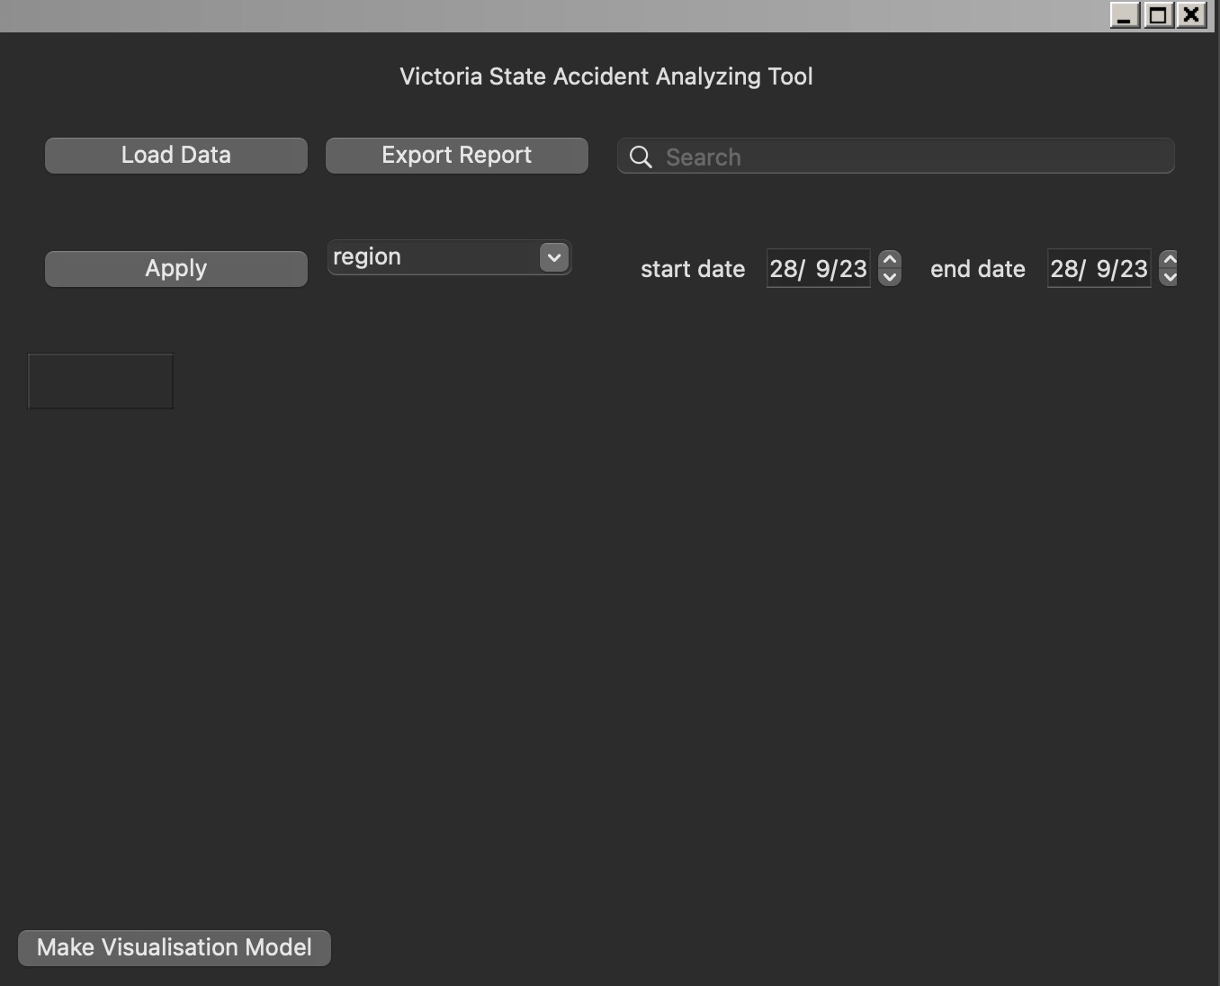

Upon entering the main screen, follow these steps:

1. Click the 'Load Data' button to load the original dataset into the table below.

2. Search Panel:

* Fill in the keyword for the accident type.
* Click the magnifier ('Search') button.
* The table updates based on the search terms.

3. Other Filters:

* Select the region of the accident.
* Define the period by setting the start and end dates.
* Click 'Apply' to update the table based on the filters.
* Note: Even though the year displays the last two digits, enter the full year (e.g., 2013, not 13).

4.Export Table:

* Click 'Export Report' to export the data table in CSV format.

5. Go Visualization:

* Click 'Make Visualization Model' to transition to the Visualization Screen.

**Visualization Screen:**

This screen is designed for building the data visualization model.

1. After clicking 'Make Visualization Model' on the main screen, the filtered data table will be 1. automatically loaded onto this screen.

2. Setting Up Visualization:

* Set the title.
* Select the x-axis, y-axis, and chart type.
* Click 'Apply' to build the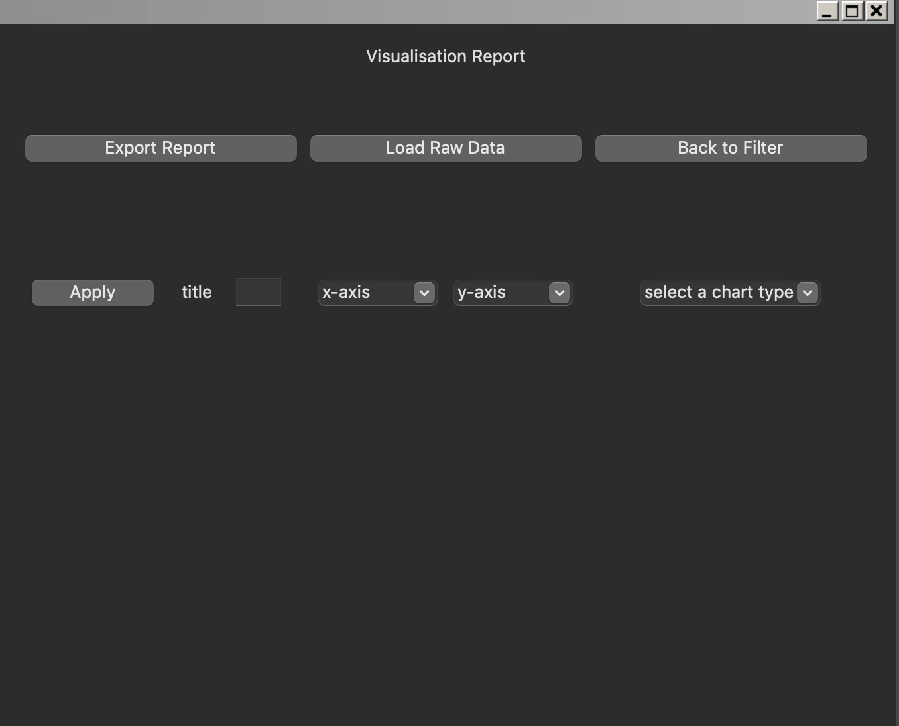 visualization model.
* (Note: Y-axis calculates the count of accidents based on the x-axis variable.)

3. Export Report:

* Click 'Export Report' to export the data visualization model as a PDF.

4. Load Raw Data:

* Click 'Load Raw Data' to use the original dataset to build the visualization model instead of the filtered table.

5. Back to Filter:

* Click 'Back to Filter' to return to the main screen.

Follow these steps for a seamless experience in navigating and utilizing both the Main and Visualization Screens.

**Result Example:**



